Usability Report-UX

MoDULE:

Knumber: K1227203, Name:dillon dhayanan

[Year]

# 

Contents

Introduction and Background 3

Aims 5

Study Method 5

Experimental Design 5

Participants 5

Tasks 6

Metrics 6

Errors 7

Time of Task 7

Success Rate 7

Materials 7

Procedure 8

Expected Result 8

Evaluation Result 8

Performance Data 8

Rating 11

Usability Issue 12

Redesign Recommendations 14

Written summary of overall findings 14

Evaluation Discussion 15

# Introduction and Background

With emerging technologies arising in the form of “Apps” (applications) through smart phones, there is an apparent market for local commuters and tourists for information sharing about social events/areas in the local area and wider circles also.

Going afar from traditional methods of advertising, mobile marketing is becoming a more feasible way of promoting local businesses or businesses in remote areas whom would not get the same attention should they have been advertised through other means. E.g. flyer distribution and leafletting. In fact, the Key Note Editorial 2015 has even stated that it is “creating opportunities for advertisers to target their audiences using this media channel”.

The rise in digital marketing is directly linked to the rise of the smart phone implying a need for research in testing the effectiveness of mobile phone Apps. Tourist Apps already exist through companies such as TimeOut and CityGuide all serving the common purpose of encouraging individuals to benefit from local businesses, shops and restaurants etc. These Apps not only locate users to their desired places but also gives access to promotional offers which is a huge bonus point.

According to Mintel’s report *The Locavore: Attitudes toward Locally-sourced Foods* (2014),

“People are looking to support small businesses and producers because they provides a boost to the local economy. Indeed, 63% of people said that they bought locally sourced food and drink items because it supported the local economy” This clearly shows that people will actively choose to support local businesses but it is also important to consider that information should be readily available.

The “Kingston first” App implemented by Kingston University of London will be the focal point of this report. This App is primarily aimed at tourists and new comers to Kingston-upon-Thames. It is a digital guide that provides information about places to visit, shop and dine with additional access to promotional offers too. Some of its key features include, mapping/navigation system, latest news in the local area, and offers available.

It has to date been seen as an excellent tool for helping customers to plan outings and essentially making the most of what Kingston has to offer in terms of facilities . In order to examine how user-friendly the “Kingston first” app is, participants will be asked to carry a set of activities using the App. (as mentioned in the Methods Section).

Below, *Figure 1* displays the type of communicable devices that visitors have used before visiting an attraction. Facebook allows companies to advertise and promote their business though a business page whereby they can present information, pictures and offers that in turn attract visitors. Mintel’s data shows that digital communication usage has increased year on year from 2012 to 2014.

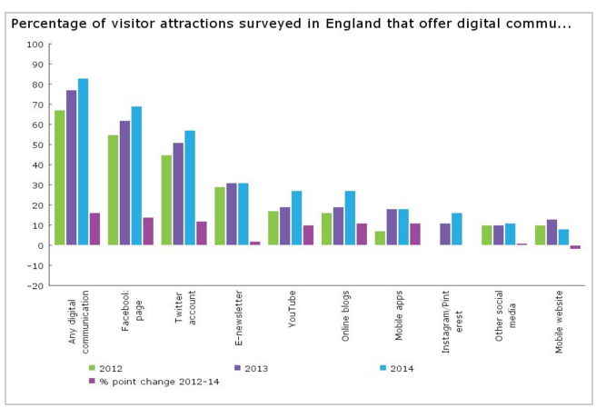

Figure 1 – Add reference

Having the capability to identify potential visitors to a location has enabled companies to specifically target these visitors with offers and local attractions. “Companies have found ways to distinguish between local people and visitors to an area using their mobile data and it has been hugely successful. “Over the 13 destinations, we identified over 129,000 tourists and succeeded in delivering more than two million marketing impressions through mobile display. While you can't reach everyone, we did successfully identify and segment a market through the use of 'data' and thus only served ads that were relevant to them.” *Add reference* This is interesting because it is a highly personalized form of advertising and shows that smart phones have become an increasingly powerful tool.

# Aims

The main aim of this project is to re-prototype “Kingston first” App based on the issues found from the previous prototype to generate a more user-friendly App. This will be achieved by asking participants to carry out a set of tasks using the App followed by survey and questionnaires. The data obtained will then be analysed.

# Study Method

## Experimental Design

The experiments were carried out at two sites; the Researcher’s residence and at Kingston University. Emails were forwarded to the participants offering the choice of the two locations, date and time of most convenience. All participants on this instance requested for Researcher’s residential place.

Five participants were recruited each of which had a one-to-one session with the Researcher on separate days from one another. An iPhone 6 was given to all participants to complete the tasks; the same device was used throughout, to rule out any discrepancies whilst navigating with the device. Video recordings were also performed using the laptop to monitor the behaviour of the participants.

## Participants

5 participants were recruited for this project out of which not all were students. There were two students, two housewives and an English teacher. All participants shared the same number of years of experience using smart phones. 3 out of the 5 were also competent with using the OS system. However, navigating with the system proved easy for all of them.

|  |  |  |  |
| --- | --- | --- | --- |
| **Participant ID** | **Gender** | **Age** | **Occupation** |
| **1** | **F** | **25-34** | **English Teacher** |
| **2** | **F** | **18-24** | **Student** |
| **3** | **F** | **46-55** | **House wife** |
| **4** | **F** | **25-34** | **House wife** |
| **5** | **F** | **25-34** | **Student** |

*Figure 2.* A table to illustrate the gender, age group and occupation of each one of the participants

## Tasks

Below is a table to show the different tasks (Tasks 1-3) that the participants were asked to complete**.** *(Figure 3)*

|  |  |
| --- | --- |
| Task 1 | Imagine you are a Tourist or Student visiting Kingston first time.  Find the nearest pub and club near the Kingston.  What is nearest club or pub in Kingston Upon Thames? |
| Answer : Succefully finds the Pub or club information and place of street | |
| Task 2 | Find Offer within Kingston Area.  Imagine you are a Tourist or Student in Kingston for the first time.  Identify the offers that are available within the Kingston Area. |
| Answer : Correctly Sblend for student and staff discount 10% off | |
| Task 3 | Find the Local news on the App  Imagine you are a Tourist or Student in Kingston for the first time.  Find the Kingston local news on the App |
| Answer : Successfully find the section of the news of Kingston pick the date of the news and title of the news. | |

First navgative within the app to find the key word “pub or bar” and the locations

Users who want to find the information of the offers that available

Navigate within the app to find the information of local news

### Task 1-Find the nearest pub and Club near the Kingston.

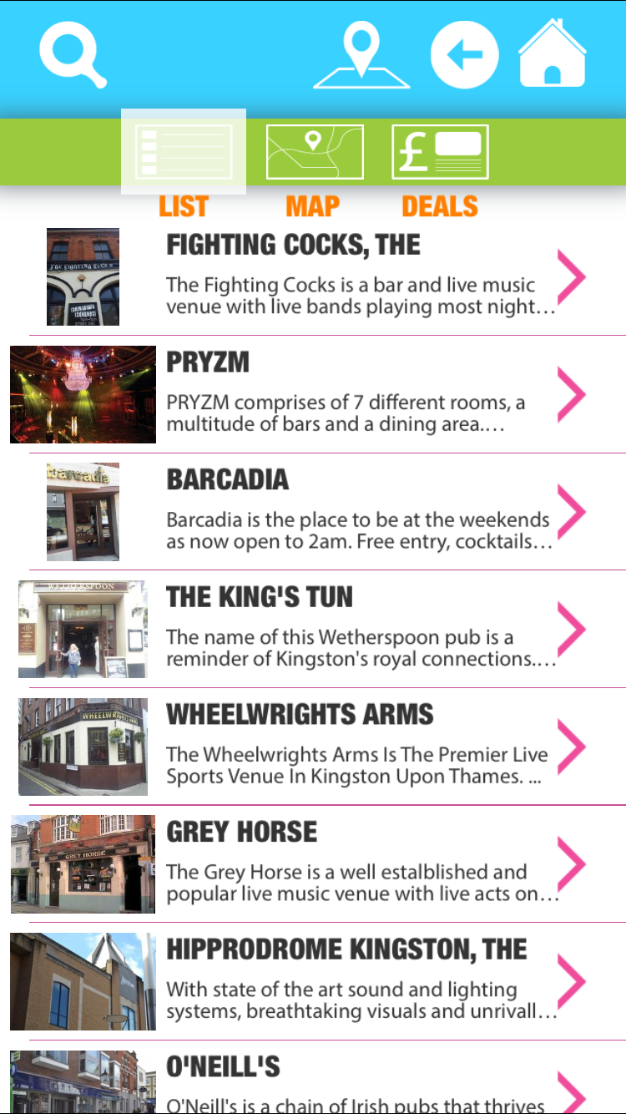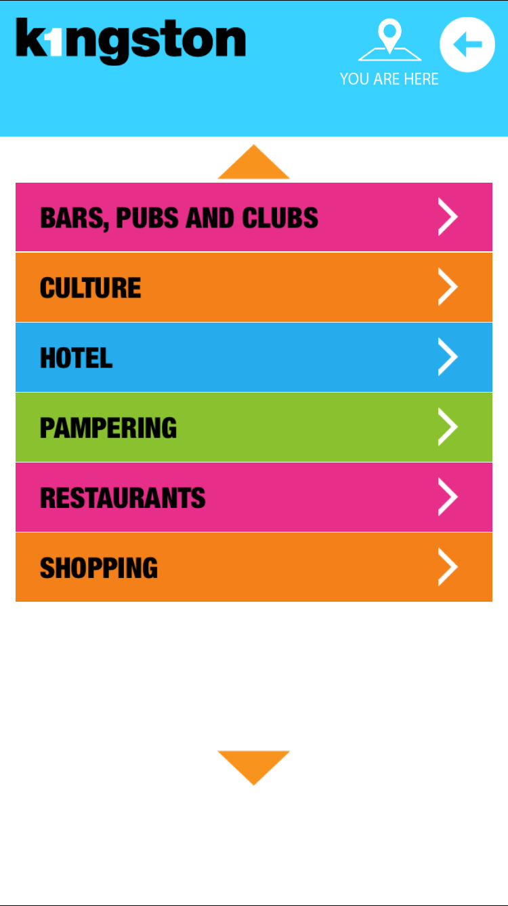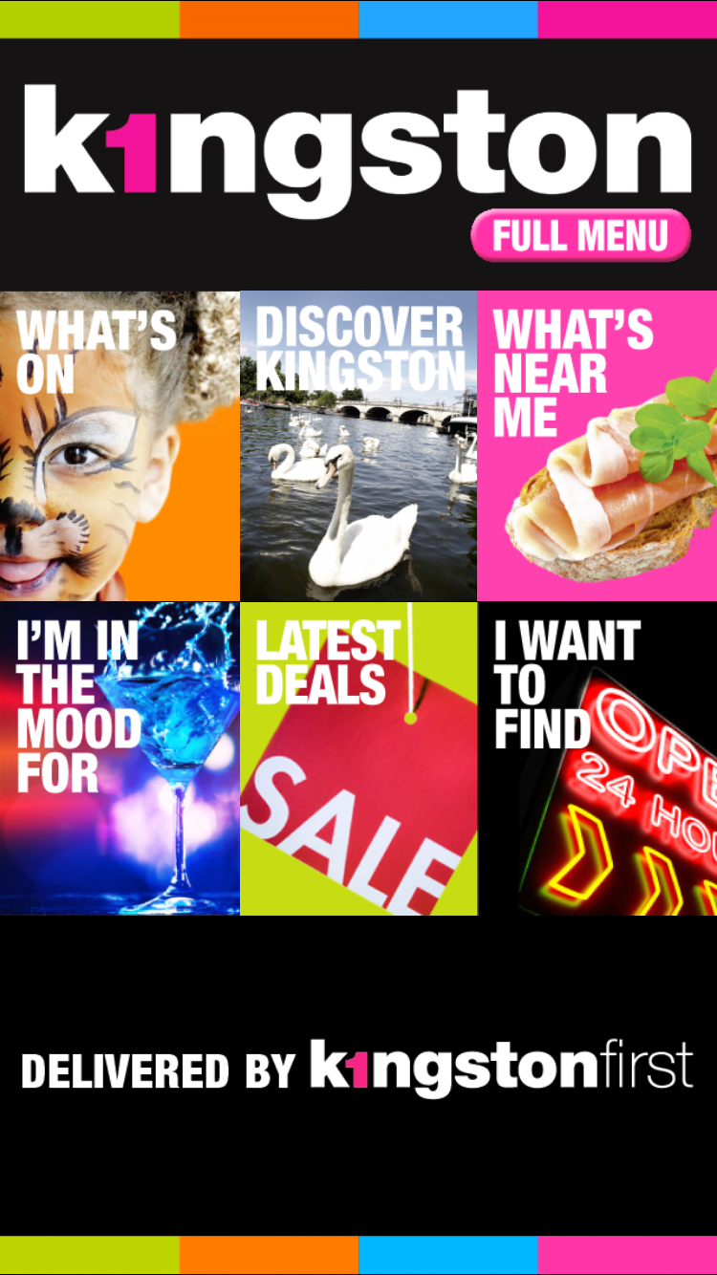

Figure 6

Figure 4

Figure 5

Outcome: In Figure 4 select “What Near Me”, then in figure 5 sub menu section will appear then Touch down on the “Bars, Pubs and Clubs”. Then result of Bars, Pubs and Club will appear on the table then users has to find either Pub or Club

### Task 2 - Identify the offers that are available within the Kingston Area.

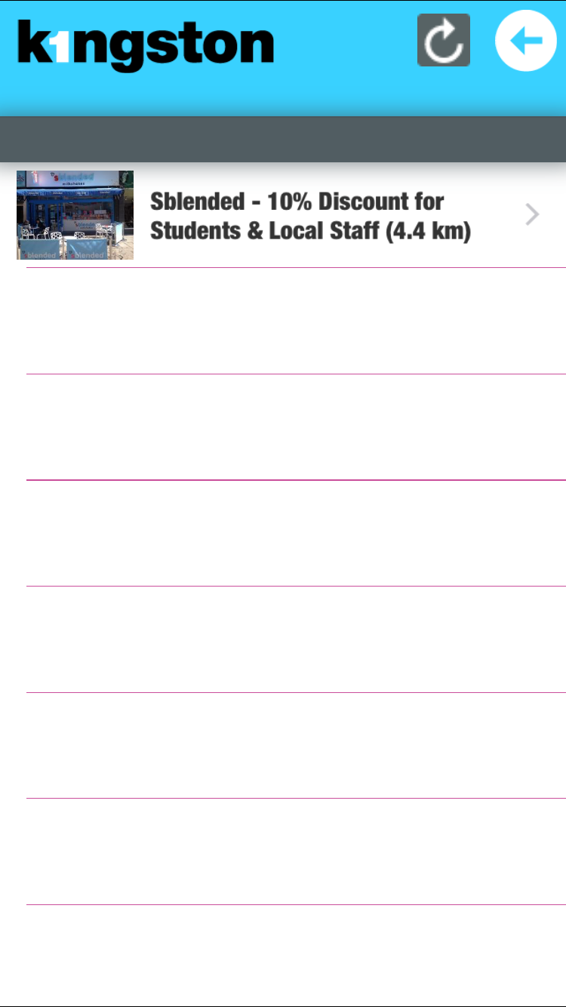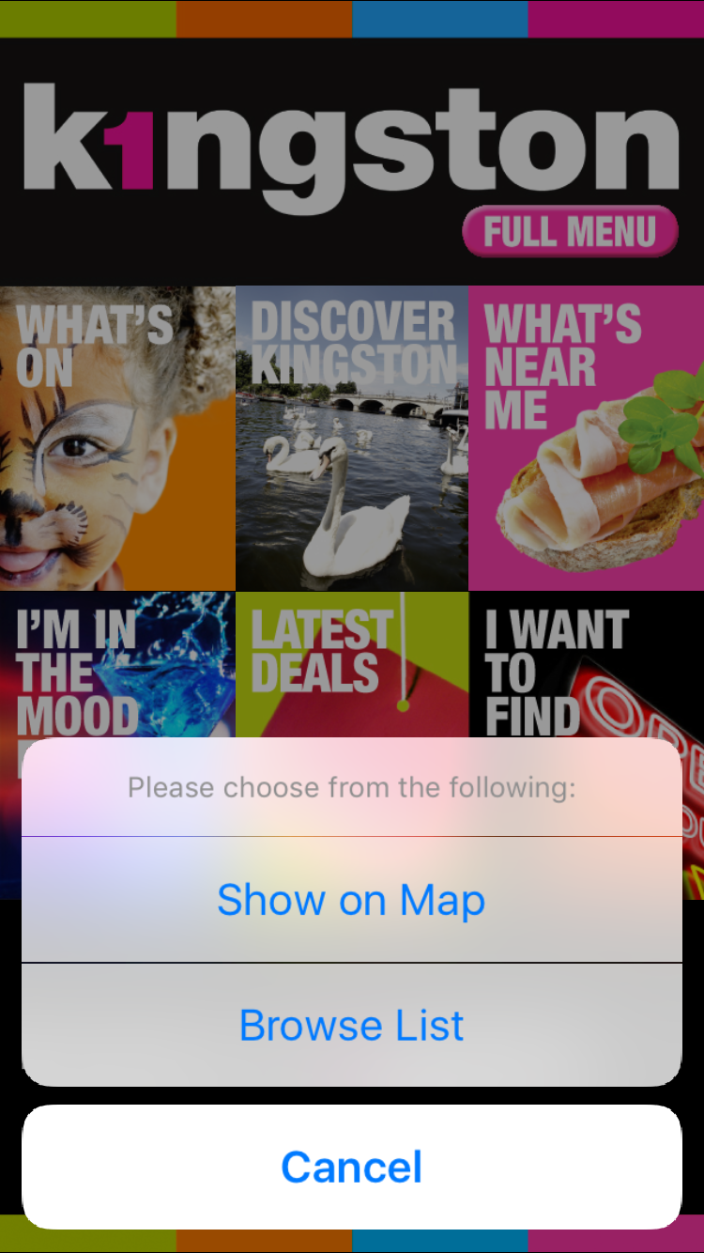

Figure 8

## 

## 

Figure 7

Figure 9

Outcome: In Figure 4 above Select “Latest Deals”, then in figure 8 it will display only one offer on the table list. Then Select the offer then the next screen will appear giving the descriptions of the offer and the vaild date for the offer.

### Task 3- Find the Kingston local news on the App

## 

Figure 10

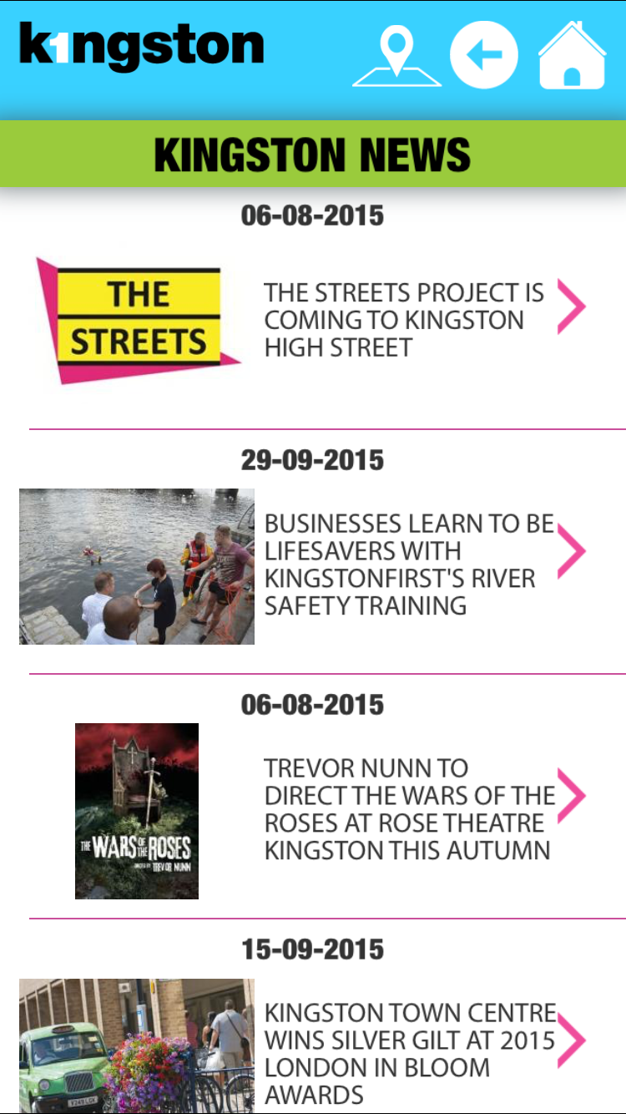

Figure 11

Outcome: in Figure 4 select “Menu” then it will direct to Menu list then in figure 10 select the Latest news then other screen will appear listing the news.

## Metrics

All participants were monitored when carrying out the tasks; observations were recording on a task sheet by the researcher. Each participant was given a score on the performance based on speed of task etc.

### Errors

This would quantify terms of the participant’s mistake and scuffle that are shown during the completing the tasks. This is an important part of the research as it gives an overview of which task the participant has made a mistake with and allows the observer to see if another participant makes the same mistake. The error will state were the participant is making the mistake and how to overcome the problem.

#### Assist

Assistance was given by the researcher to the participant in the session by word of mouth when they requested so. This demonstrated the amount of time the participant would achieve a task without the required help from the researcher.

### Time of Task

The time taken to complete each of the tasks was recorded by the researcher to analyse the response reaction.

### Success Rate

The success rate is assessed on how successful each of the participants were on completing each of the tasks. Once the participant had completed the task, the researcher would see if they were successful or failed and this was noted on the observation sheet.

## Materials

Participant:

* Consent Form
* Screen Questionnaires
* Task Sheet
* MacBook Pro OSX(X El Capitan, Word)
* Post-Questionnaire
* IPhone 6 (iOS9,Tasks Instructions )

Researcher:

* Task Observation sheet
* MacBook Pro OSX(X El Capitan)
* Word Processor
* Air Server- Recording the Participant IPhone Screen

**Test Environment/Conditions**

All one-to-one sessions were carried out at the Researcher’s residence. A MacBook pro laptop was used for the video recording. All participants used an iPhone 6OS to use the “Kingston first” App and to also prevent biases should other devices such as Android had had been used.

All participants consented by completing an agreement which included acceptability of video recording for training purposes. The agreement also mentioned that when a task has begun that you must attempt to complete regardless of whether you were capable of completing it.

In addition, participants adhered to not disclosing any information during the session to any of the other participants.

The researcher used an Air Server, which mirrors the device. The Device that was used during the test is iPhone, which will require the installation of an app on the device. The Air Server can only be installed on the OSX and no other windows because it does not not support the package for the windows.

In addition to the video recordings, the researcher used MS Word to comment on further qualitative findings. After the tasks were completed, the participants on word processor completed a post-questionnaire.

## Procedure

1. Participant arrives at researcher’s residential place to commence usability testing on the “Kingston first” App.
2. Participant is given a consent form to agree with terms and condition of the usability test.
3. Participant is asked to fill in the task answer before that they must use the equipment to answer the question on the instruction Task.
4. Conversation between Participant and Researcher regarding the difficulty of the tasks
5. Participant completes post-questionnaire
6. Participant will be notified by email if there are any additional comments from the participants.

## 

## Expected Result

One would predict that from beginning to end of the tasks that participants would be more at ease especially after completing Task 1. This assumption is based on the fact that the individuals would build upon their visual thinking when they are dictated specific keywords by the Researcher. For example, in response to finding a “pub”, the participant would navigate toentertainment/food section of the App.

In light of this assumption, one would also predict that post-questionnaire would be highly scored by the participants. However, biases could occur as other factors such as the differences educational background (i.e. fluency in IT Literacy), socio-economic status etc. across the participants may have affected their performance scores. When considering these predictions, one would believe that aims of objectives of this project would be met successfully.

# Evaluation Result

## Performance Data

Task 1 Find nearest pub or Club

Time (mean): 2.4mins

Problems:

2 out of 5 users went into the menu scrolled down the list they didn’t meet the 2 minute mark they went over the time but they found the answer.

3 out of 5 Participant found the task easier and straightforward and they said the layout was bit similar to other apps.

|  |  |  |  |  |
| --- | --- | --- | --- | --- |
| **Participant** | **Successful** | **Task min** | **Error** | **Assist** |
| **1** | **100%** | **2** | **0** | **0** |
| **2** | **100%** | **2** | **0** | **0** |
| **3** | **100%** | **2** | **0** | **0** |
| **4** | **100%** | **3** | **1** | **0** |
| **5** | **60%** | **3** | **1** | **0** |
| **Total** |  | **12** | **2** | **0** |
| **Mean** |  | **2.4** | **0.4** | **0** |

**Task 2- Find the Offer in Kingston**

Time (mean):5mins

1 out of 5 participant needed help to find the offers that were available on Kingston First.

4 out of 5 participant found the task much easier and there was no assists needed.

|  |  |  |  |  |
| --- | --- | --- | --- | --- |
| **Participant** | **Successful** | **Task min** | **Error** | **Assist** |
| **1** | **100%** | **2** | **0** | **0** |
| **2** | **100%** | **2** | **0** | **0** |
| **3** | **100%** | **2** | **0** | **0** |
| **4** | **80%** | **3** | **0** | **1** |
| **5** | **100%** | **2** | **0** | **0** |
| **Total** |  | **10** | **0** | **0** |
|  |  | **5** | **0** | **0.2** |

**Task 3 - Find the Local news of Kingston**

**Time (mean):2.8**

2 out of 5 participant who went on the menu list were confused to find the news sections but they kept on looking for it until they clicked on a different section on the menu. The participants asked for assistance to direct them to the right sections of the screen.

3 out of 5 participants found the task much easier and completed the task without any errors or assistance during the test.

|  |  |  |  |  |
| --- | --- | --- | --- | --- |
| **Participant** | **Successful** | **Task min** | **Error** | **Assist** |
| **1** | **100%** | **2** | **0** | **0** |
| **2** | **100%** | **4** | **1** | **1** |
| **3** | **100%** | **2** | **0** | **0** |
| **4** | **60%** | **2** | **0** | **0** |
| **5** | **60%** | **4** | **1** | **1** |
| **Total** |  | **14** | **2** | **2** |
| **mean** |  | **2.8** | **0.4** | **0.4** |

### 

### Rating

**Task 1. Find nearest pub or Club**

|  |  |  |  |
| --- | --- | --- | --- |
| **Participant** | **Frustration** | **Satisfaction** | **Convenience** |
| **1** | **6** | **3** | **5** |
| **2** | **1** | **2** | **7** |
| **3** | **6** | **5** | **4** |
| **4** | **6** | **1** | **1** |
| **5** | **7** | **1** | **1** |
| **Total** | **26** | **12** | **18** |
| **Mean** | **5.2** | **2.4** | **3.6** |

**Task 2. Find the Offer in Kingston**

|  |  |  |  |
| --- | --- | --- | --- |
| **Participant** | **Frustration** | **Satisfaction** | **Convenience** |
| **1** | **2** | **2** | **4** |
| **2** | **6** | **4** | **7** |
| **3** | **2** | **6** | **6** |
| **4** | **6** | **1** | **6** |
| **5** | **4** | **7** | **6** |
| **Total** | **20** | **20** | **29** |
| **Mean** | **10** | **10** | **5.8** |

**Task 3. Find the Local news of Kingston**

|  |  |  |  |
| --- | --- | --- | --- |
| **Participant** | **Frustration** | **Satisfaction** | **Convenience** |
| **1** | **2** | **2** | **5** |
| **2** | **6** | **4** | **7** |
| **3** | **2** | **6** | **4** |
| **4** | **6** | **1** | **1** |
| **5** | **4** | **7** | **1** |
| **Total** | **26** | **12** | **18** |
| **Mean** | **5.2** | **2.4** | **3.6** |

Overall the rating table for the task has shown a significant result.  The table displaying the data has, shown task 1 and task 3 are both frustrating due to the layout of the app structure and also the experience of using the app.   Task 2 has scored more than task1 and task3 because of the satisfaction of using the Kingston first app and finding the offers that are available. Task 2 was more convenient as using the app it was easy to find the information, whereas in task 1 and task 3 it was not convenient using the app.

## Usability Issue

|  |  |  |  |
| --- | --- | --- | --- |
| ID | Issue | Recommendations | Priority |
| 1 | 2 / 5 participants were confused and frustrated by the navigation to the section of pub or club.  The start of the menu screen displaying the image was too small, the image size in pixel is 32*32, this size is very small. The structured layout used to group the thumb image is squeezed together will no space left .  The use of Map to find the pub or clubs was not useful to the participants because it was only showing the shadow map and it was too dull for participants to use. Colour was not great on the App  The pub or club info section of information of text was not spaced out and use of size was poor and the fonts style was not readable texts. | Image thumb for the menu screen can be larger and the layout for the image thumb will be displayed as rectangle within image.  Change the background colour to light or dark colour that match layout and the texts.  The pub and club info sections must be formatted into better font size for the user and font style could be change into fancy text. | High |
| 2 | 1 / 5 participants could not find the Latest Deals due the name called Latest Deal most call it as Latest Offer.  The Latest Deal has a pop menu allowing the user to choose the options, this is confusing because the user is not sure which of the menu functions is to be used.  There is no image icon to indicate within the pop menu of Offers.  In the offers sections it shows the information but the text is like small chunk of text placed on the body of the offer section. | Renaming the main menu from Latest Deal to Latest offer will help the users.  The pop up menu for the Latest deal should have some icons to indicate each of the menu list.  The offers info the text should be bold and use bright colours.  The title of the offer should be shortened. The text can be broken down to individual text to bring the message to the users of the Offer. | Low |
| 3 | 2 / 5 Participants found finding the latest news difficult because on the main screen there is no Latest news image thumb link to the section. It is hard to find so it is not visible to the participants .  The text could be broken down into a paragraph and the use of the colour in outer layout of body needs to change because it loses connection with the message the local new is trying to mention. | In the main menu screen there could be a thumb image for the latest news which will help users and the response time would be much quicker instead of going on to many section to get into the section.  The outer layer body of the text background colour could be blended with the text so it synchronizes with the reader or users. | High |

## Redesign Recommendations

* Main Menu
  + Image thumbnail size
  + Sub-menu
* Pub or Club section screen
  + Map
  + Text on the body of the sections
* Offers Section screen
  + Title of the offer
  + Pop Menu
  + Body text message
* Latest News Sections

Overall, this section and the internal of the section must be changed due to the visibility of using the app. Errors occur on the main menu screen and section because the text, style and use of fonts is not synchronized with the user. Readability is very important and the app should make this clear to the consumer. The design is not structured and it is not coherent because the process is not logical. All sections need to be one touch.

## Written summary of overall findings

Overall, the results show that 2 out of 5 participants found task 1 difficult to complete because they struggled to locate the pub or club within the app. The rest of the participants found using the app easy because they were able to relate the layout to other apps. 3 of the participants said, the Kingston first App was easy to use. 1 participant enjoyed looking through app and answering the questions.

1 out of 5 participants made errors within task 2.  They found it difficult to find the latest deal and choose which list to select on the pop menu. The use of 'Latest Deals' did not catch one of the participants eye whereas the rest of the participants already knew what latest deal meant.

In task 3, finding the latest local news in Kingston, 2 out of 5 participants took longer because the button is hidden within the submenu.  There the issue could be solved for the each task by limiting the putting the button in a more prominent place.

## Evaluation Discussion

During the usability test more participants should have joined .The researcher would have more data to support the problem with user experience for Kingston first App. The research could have made the task more interesting but due to the fact that the Kingston first App is only about displaying information of Kingston and local business it was difficult to make the task instructions fun for the participant to do.

The app has not be maintained with the right information.

 However, during my external research looking at journals it has come across that this is related to the app and the research. Although the research has been done about Mapping the tourism with mobile application it has a relationship with the Kingston first because there are trying to use the Map for location the local business and tourist attraction (Zarmpou, Drosopoulou and Vlachopoulou, 2013)

. To finalize the evaluation discussion the results I have come to have pointed out major and smaller issues.  It was difficult to create more tasks because there were difficulties with the app and it did not run efficiently. I had some biased result because of I did not have many participants join the trial and there was less time to complete the usability research.

# Appendix



**Participants Needed for Usability Test!**

We are improving a Travel Guide App easier to use, and need some feedback from potential users.

Can you help?

Feedback sessions will take place in Kingston University’s Usability Lab., at Penrhyn Rd. campus, between Monday 23th October and Friday 27th November, 2015.

Each session is expected to last 40 min to 1 hour, and can be arranged for a convenient time. You will be asked to use the website to make some travel plans, and tell us how easy to use you found it.

Participants who complete the session will receive a £20.00 gift voucher for Marks & Spencer, or John Lewis Department Stores.

If you would like to participate, please

Thank you for your interest!

Email: [k1227203@kingston.ac.uk](mailto:k1227203@kingston.ac.uk)

Dillon Dhayanandan,

Kingston University

**Participant Screening Questionnaire**

1. Have you participated in a usability test before? Yes No
2. What is your age?

|  |  |  |  |  |
| --- | --- | --- | --- | --- |
| 18-24 | 25-34 | 35-45 | 46-55 | over 55 |

1. Are you student? Yes | No
2. What is your Employment Status ?
3. What brand is your smartphone?

**Answer:**

1. How long have you been using the Smartphone?

|  |  |  |  |  |
| --- | --- | --- | --- | --- |
| over 5 years | 3-5 years | 2-3 years | about a year | less than a year |
|  |  |  |  |  |

1. What type of operating systems is being used on your Smartphone?

Android **IOS** Window 8.1 OS Linux

1. What do you use the Smartphone for?

………………………….………………………………………………….

9 Have you used a tuorist guide before? Yes No

1. Have planned the jounery using the APP before? Yes No
2. What app did you use to plan the journey?

12 When was the last time you used an Tourist App?

|  |  |  |  |  |
| --- | --- | --- | --- | --- |
| Daily | Weekly | Monthly | Yearly | Never |

**Participant Information Sheet**

**Purpose:** The purpose of this session is to assess the ease of use of KingstonFirst App, compared to industry benchmarks and to improve the design of its user interface.

**Tasks and duration:** You will be asked to:

* tell us a little about yourself as a user;
* perform 3 tasks on KingstonFirst App;
* Give us some feedback about your experience.

The session will last approximately 30 minutes.

**Right to withdraw:** You may withdraw from the session at any time without prejudice or you need not answer any specific question if you prefer not to.

**Potential of risk or discomfort:** This study has no side effects and will not impose any harm to you physically or mentally.

**Anonymity/confidentiality:** Your identity will be anonymous. All data will be stored using a participant number, and will only be used for the purposes of the research. All data that might identify individuals will be destroyed by December 1st, 2014, when we anticipate that the project and its publications will reach its completion. In the reporting of the project, no information will be released which will enable a reader to identify who our participants were.

If you have any questions, please ask the moderator.

If you agree to participate in this study, please read and sign this consent form.

**Informed Consent**

**Statement by participant #** ……..

* I confirm that I have read and understood this information sheet and the invitation to participate.
* I understand:
  + the purpose, risks, and benefits of taking part in this session.
  + what my involvement will entail and any questions have been answered to my satisfaction.
  + that my participation is entirely voluntary, and that I can withdraw at any time without prejudice.
  + that all information obtained will be confidential.
  + that research data gathered for the study may be published provided that I cannot be identified.
* Contact information has been provided should I wish to seek further information from the investigator at any time for purposes of clarification.

Participant’s Signature …………………………………… Date: …………………..

**Statement by investigator**

* I have explained this study and the implications of participation in it to this

participant without bias and I believe that the consent is informed and that he/she understands the implications of participation.

Name of investigator: ………………………………………………………….

Investigator’s Signature …………………………………… Date: ………………….

**TASK SHEET 1**

Please read the instructions on this sheet carefully, and then tell me what you have understood you have been asked to do.

1. **Find the nearest pub in Kingston**

Imagine you are a Tourist or Student visiting Kingston first time.

Find the nearest pub and Club near the Kingston.

Please **don’t send** the APP to A Friend

When you believe you have finished the task, please enter your Answer in the box below, and tell the moderator you believe you have finished.

**ANSWER**

What is nearest club or pub of Kingston Upon Thames ?

Name of the Place ………..………….

Locations………………………………

**TASK SHEET 2**

Please read the instructions on this sheet carefully, and then tell me what you have understood you have been asked to do.

1. **Find Offer within Kingston Area.**

Imagine you are a Tourist or Student Kingston first time.

Identify the offers that are available within the Kingston Area.

When you believe you have finished the task, please enter your Answers in the box below, and tell the moderator you believe you have finished.

**ANSWERS**

Street Name: …………………………….

Offers Name: …………………………….

Date of Expiry of the offer: …………………………….

**TASK SHEET 3**

Please read the instructions on this sheet carefully, and then tell me what you have understood you have been asked to do.

1. **Find the Social Network**

Imagine you are a Tourist or Student Kingston first time.

Find the Kingston local news on the App

**ANSWERS**

Title of the News: ...........................

Date of the News: ...........................

Is there any Like page: Yes/NO

### Post-Test Questionnaire

Please circle the number that best expresses the strength of your agreement or disagreement with the following statements

|  | **disagree ----------------------------------- agree** | | | | | | |
| --- | --- | --- | --- | --- | --- | --- | --- |
| 1. The main screen of the app was very attractive. | 1 | 2 | 3 | 4 | 5 | 6 | 7 |
| 1. I don’t like the use of different color scheme of the menu. | 1 | 2 | 3 | 4 | 5 | 6 | 7 |
| 1. All menu buttons were clearly visible. | 1 | 2 | 3 | 4 | 5 | 6 | 7 |
| 1. The walking icons are pleasant. | 1 | 2 | 3 | 4 | 5 | 6 | 7 |
| 1. Did the app loaded very quickly. | 1 | 2 | 3 | 4 | 5 | 6 | 7 |
| 1. It was easy to navigate around the App. | 1 | 2 | 3 | 4 | 5 | 6 | 7 |
| 1. The top icon like the back and home button was it is to indicate where the button was on the App. | 1 | 2 | 3 | 4 | 5 | 6 | 7 |
| 1. I could find the pub and bars within Kingston using the App. | 1 | 2 | 3 | 4 | 5 | 6 | 7 |
| 1. I could find the current location and the bars location it would tell me how long is my destination to the bar. | 1 | 2 | 3 | 4 | 5 | 6 | 7 |
| 1. It was easy find the location of Clubs within Kingston. | 1 | 2 | 3 | 4 | 5 | 6 | 7 |
| 1. It was satisfied Search could find the result of the place in Kingston. | 1 | 2 | 3 | 4 | 5 | 6 | 7 |
| 1. It was easy for me find the location on the Arts and Craft. | 1 | 2 | 3 | 4 | 5 | 6 | 7 |
| 1. It was easy to find the descriptions for the CASS ART. | 1 | 2 | 3 | 4 | 5 | 6 | 7 |
| 1. I knew instantly what each icon meant. | 1 | 2 | 3 | 4 | 5 | 6 | 7 |
| 1. It was easy to find the map on the app. | 1 | 2 | 3 | 4 | 5 | 6 | 7 |
| 1. The search result was helpful message. | 1 | 2 | 3 | 4 | 5 | 6 | 7 |
| 1. The search result was highlighting the message | 1 | 2 | 3 | 4 | 5 | 6 | 7 |
| 1. It was easy to find the information of the shops within Kingstonfirst app. | 1 | 2 | 3 | 4 | 5 | 6 | 7 |
| 1. It was easy to find the events schedule of the show for the rose theatre. | 1 | 2 | 3 | 4 | 5 | 6 | 7 |
| 1. I was satisfied with the information of the news within Kingston. | 1 | 2 | 3 | 4 | 5 | 6 | 7 |
| 1. The App layout was well laid out on the menu screen | 1 | 2 | 3 | 4 | 5 | 6 | 7 |
| 1. The App was easy to navigate with other screen pages within the App and the layout was consistence | 1 | 2 | 3 | 4 | 5 | 6 | 7 |
| 1. I would recommend this APP to my friends or family. | 1 | 2 | 3 | 4 | 5 | 6 | 7 |

1. During the experience of using the App, how easy was it to use the Kingston First App ?

Not at all easy 1 2 3 4 5 6 7 Very Easy

1. How well ordered was it to use the Kingston First App?

Not at all well ordered 1 2 3 4 5 6 7 Very

Well ordered

1. How friendly was it to use the Kingston First App?

Not at all friendly 1 2 3 4 5 6 7 Very friendly

1. How easy was to learn the Kingston First App?

Not at all learnable 1 2 3 4 5 6 7 Very

learnable

**TASK SHEET 1 task order in this session: . . . . . . . . .**

1. Find the nearest pub and Club near the Kingston. **start time: stop time: duration:**

What is nearest club or pub of Kingston Upon Thames ?

**PARTICIPANT # ………………..**

Answer:

Assists:

Errors:

Help:

Note from observation:

**Low =1 and High =7**

Frustration:

Convenience :

Satisfaction:

**TASK SHEET 2 task order in this session: . . . . . . . . .**

1. **Find offer start time: stop time: duration:**

Identify the offers that are available within the Kingston Area.

**PARTICIPANT # ………………..**

Answer:

Assists:

Errors:

Help:

Note from observation:

**Low =1 and High =7**

Frustration:

Convenience :

Satisfaction:

**TASK SHEET 3 task order in this session: . . . . . . . . .**

1. **Find the local news start time: stop time: duration:**

Find the Kingston local news on the App

**PARTICIPANT # ………………..**

answer

Assists:

Errors:

Help:

Note from observation:

**Low =1 and High =7**

Frustration:

Convenience :

Satisfaction:

# References

Zarmpou, T.,, Drosopoulou, C., and Vlachopoulou, M., 2013. Mapping the tourism mobile applications: what, how and where. In: *Proceedings of the 6th Balkan Conference in Informatics*. [online] ACM, pp.206–212. Available at: <http://dl.acm.org/citation.cfm?id=2490295> [Accessed 1 Jan. 2016].

[http://academic.mintel.com.ezproxy.kingston.ac.uk/trends/#/observation/759114?highlight#hit1](http://academic.mintel.com.ezproxy.kingston.ac.uk/trends/#/observation/759114?highlight)

**https://www-keynote-co-uk.ezproxy.kingston.ac.uk/market-update/media-marketing/direct-marketing?full_report=true**

Mintel's report *The Locavore: Attitudes toward Locally-sourced Foods – US, February 2014*.)”

Key Note Editorial, 2015